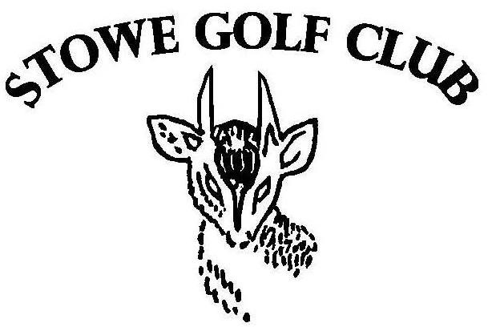

MEMBERSHIP RENEWAL FORM

MEMBERSHIP RENEWAL FORM 2022-2023

Please complete in BLOCK CAPITALS

TITLE

FIRST NAME

SURNAME

ADDRESS

POSTCODE

TELEPHONE

EMAIL

CAR 1 MAKE AND REGISTRATION

CAR 2 MAKE AND REGISTRATION

MEMBERSHIP TYPE (PLEASE TICK)

- FULL MEMBER £400.00

- SENIOR MEMBER * £275.00

- LADY MEMBER £275.00

- JUNIOR MEMBER (16-18) £163.00 DATE OF BIRTH………………...

- JUNIOR MEMBER (U16) £50.00 DATE OF BIRTH…………………

- COUNTRY MEMBER * £230.00 Distance to course (miles)……

Membership runs from your join date until the 31st of March 2023
NOTES

*SENIOR MEMBERSHIP IS OPEN TO GENTLEMEN MEMBERS WHO HAVE BEEN A FULL 7 DAY MEMBER FOR AT LEAST 2 YEARS AND ARE OVER 60 YEARS OF AGE.

*COUNTRY MEMBERS MUST LIVE 50 MILES OR MORE FROM THE COURSE.

*THROUGHOUT THE YEAR THERE ARE TIMES WHEN WE NEED TO SHARE YOUR PERSONAL DETAILS INCLUDING NAME, ADDRESS, TELEPHONE NUMBER AND EMAIL ADDRESS TO THE COMMITTEE OF STOWE GOLF FOR THE PURPOSE OF THE ADMINISTRATION OF THE HANDICAP SYSTEM AND COMMUNICATION IN RESPECT OF EVENTS AND CLUB UPDATES.

PLEASE TICK THIS BOX TO CONFIRM THAT BASED ON THE ABOVE YOU ARE HAPPY FOR YOUR PERSONAL DETAILS TO BE SHARED WITH THE COMMITTEE OF STOWE GOLF.

I CONFIRM TO MY DETAILS BEING SHARED

*FOR 2023-24 WE ARE LOOKING INTO INTRODUCING A 7 DAY AND 5 DAY MEMBERSHIP OPTION- PLEASE COULD YOU TICK THE BOX BELOW WHICH OPTION YOU WOULD BE INTERESTED IN?

7 DAY MEMBERSHIP 5 DAY MEMBERSHIP

PAYMENT

BACS:
Please remember to use your full name as a reference

Stowe Enterprises Limited
Barclays Bank, Banbury Branch
Sort code: 20-03-50
Account Number: 70519006

If you would prefer to pay by cheque, please make these out to Stowe Enterprises Limited and return to:

Stowe Enterprises Ltd

Stowe School

Buckingham

Bucks

MK18 5EH

Please return this form via email to events@stowe.co.uk

