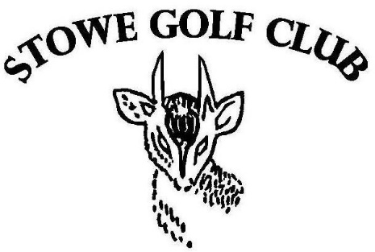

OLD STOIC MEMBERSHIP FORM

OLD STOIC MEMBERSHIP RENEWAL FORM
2022-2023

Please complete in BLOCK CAPITALS

TITLE

FIRST NAME

SURNAME

HOUSE

YEAR LEFT STOWE ……………………………………………………………………………………………………………

ADDRESS

POSTCODE

TELEPHONE

EMAIL

CAR 1 MAKE AND REGISTRATION

CAR 2 MAKE AND REGISTRATION

MEMBERSHIP TYPE (PLEASE TICK)

- OLD STOIC £180.00

Membership runs from your join date until the 31st of March 2023

PAYMENT for Old Stoic Membership:

BACS:
Please remember to use your full name as a reference

£180 Membership Fee
Stowe Enterprises Limited
Barclays Bank, Banbury Branch
Sort code: 20-03-50
Account Number: 70519006

If you would prefer to pay by cheque, please make these out to Stowe Enterprises Limited and return to:

Stowe Enterprises Ltd

Stowe School

Buckingham

Bucks

MK18 5EH

Please return this form via email to events@stowe.co.uk

THROUGHOUT THE YEAR THERE ARE TIMES WHEN WE NEED TO SHARE YOUR PERSONAL DETAILS INCLUDING NAME, ADDRESS, TELEPHONE NUMBER AND EMAIL ADDRESS TO THE COMMITTEE OF STOWE GOLF FOR THE PURPOSE OF THE ADMINISTRATION OF THE HANDICAP SYSTEM AND COMMUNICATION IN RESPECT OF EVENTS AND CLUB UPDATES.

PLEASE TICK THIS BOX TO CONFIRM THAT BASED ON THE ABOVE YOU ARE HAPPY FOR YOUR PERSONAL DETAILS TO BE SHARED WITH THE COMMITTEE OF STOWE GOLF.

I CONFIRM TO MY DETAILS BEING SHARED

