Stowe School
A-level Biology
Bridging Work Booklet

Name: ____________________

STOWE Biology A Level Bridging Work

Welcome to STOWE Biology!

This bridging work is designed to help you to bridge the gap between GCSE Biology and the AQA A Level Biology course.

Why do bridging work?
Preparation is crucial for studying A Level Biology. After completing these exercises you will need to highlight any areas that you really had trouble understanding. All of these are essential in the understanding of the foundations of biology.

Bridging work should help you to gauge your current understanding of the subject and introduce you to the depth of understanding that is required for study at post-16.

Is the bridging work assessed?
Yes. In September, your subject teacher will ask you for your bridging work and it will be assessed. Teachers can diagnose your strengths and weaknesses and begin to support you in a more targeted way.

Biology A-level
As part of your A-Level studies you will have six 55 minute lessons each week in your timetable. The syllabus is split between two teachers who will have 3 lessons each per week with you. In these lessons you will cover all the theory and practical work required for the course. You are also expected to spend at least four hours a week on your Biology work outside of lessons. This will include Prep tasks, pre-reading, independent study tasks, making additional notes, reviewing lesson materials and reading around the subject. To allow you to make a start on this, a suggested reading list has been included at the end of this booklet.

Your A Level Biology Qualification will cover the following 8 units:
- Biological molecules
- Cells
- Organisms exchange substances with their environment
- Genetic information, variation and relationships between organisms
5. Energy transfers in and between organisms
6. Organisms respond to changes in their internal and external environments
7. Genetics, populations, evolution and ecosystems
8. The control of gene expression
You will sit two examination papers at the end of the Upper Sixth:
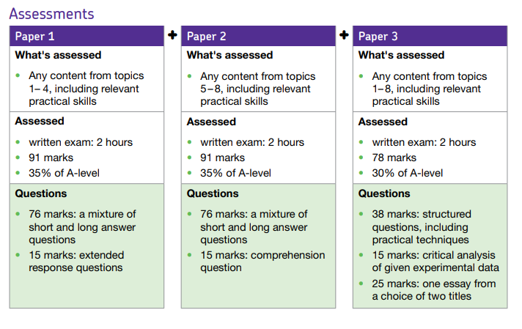

You should bring this bridging work with you to your first Biology lesson in September.

Above and beyond work: bring a journal article about something interesting you have read or researched over the summer.

If you need to do more preparation……

To support your learning you will be provided with a textbook for the current A Level course in September. Your teachers are, of course, an excellent source of support both in and out of lessons. Other support includes drop-in support clinics outside of lessons, a Biomedical Society (for those wishing to study medicine/Biological sciences after A levels) and further Biology enrichment opportunities to help support your studies.

Additional texts will be available in the Biology and Science library and a full copy of the specification, past papers etc. can be accessed through the AQA website: http://www.aqa.org.uk/subjects/science/as-and-a-level/biology-7401-7402

Places to go for help

- AQA website is a great place to start their Biology webpages are aimed at teachers, but you may find them useful too.

Information includes:

• The specification – this explains exactly what you need to learn for your exams.
• Practice exam papers
• Lists of command words and subject specific vocabulary – so you understand the words to use in exams
• Practical handbooks explain the practical work you need to know
• Past papers and mark schemes from the old specifications. Some questions won’t be relevant to the new AS and A-level, so please check with your teacher.
• Maths skills support

- Royal Society of Biology “A single unified voice for biology”.

They work with everyone from government policy makers to students, as well as universities and researchers studying biology. Their website includes a dedicated student section. Have a look at rsb.org.uk

- The student room

Join the A-level Biology forums and share thoughts and ideas with other students if you’re stuck with your prep. Visit thestudentroom.co.uk

- Textbooks

We use the approved textbook are published by Oxford University Press. Textbooks from other publishers will also be suitable, but you’ll need to double check that the content and formula symbols they use match the AQA specification.

- Revision guides

These are great if you want a quick overview of the course when you’re revising for your exams. Remember to use other tools as well, as these aren’t detailed enough on their own.

- YouTube

YouTube has thousands of Biology videos. Just be careful to look at who produced the video and why because some videos distort the facts. Check the author, date and comments – these help indicate whether the clip is reliable. If in doubt, ask your teacher.

- Magazines Focus

New Scientist or Philip Allan updates can help you put the biology you’re learning in context.

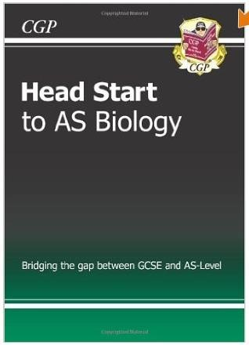
- Try ‘Head Start’ to AS Biology. This covers the content that we will be studying in the Lower Sixth.

- Buy on line at: https://www.cgpbooks.co.uk/

- ISBN 978 -1847621177

- Only £4.95!

- It recaps all the tricky topics from GCSE that AS builds on. It is ideal preparation for September no matter what GCSE option you have followed. It will also be useful for reference throughout the course.

A-Level Biology recommended reading:

Websites
- http://www.ibiblio.org/virtualcell/index.htm – An interactive cell biology site
- http://www.accessexcellence.org/RC/VL/GG – A web site showing illustrations of many processes of biotechnology
- http://www.uq.oz.au/nanoworld – Visit the world of electron-microscopy
- http://www.dnai.org/a/index.html – Explore the genetic code
- http://nobelprize.org – Details of the history of the best scientific discoveries
- http://nature.com – The site of the scientific journal
- http://royalsociety.org – Podcasts, news and interviews with scientists about recent scientific developments
- http://www.nhm.ac.uk – The London Natural History Museum’s website with lots of interesting educational material
- http://www.bmj.com – The website of the British Medical Journal
- http://www.bbc.co.uk/news/science_and_environment - The BBC news page for Science and the Environment
Books
Research these on Amazon and select a few to read:

Richard Dawkins:
The Selfish Gene
The Blind Watchmaker.
Unweaving the Rainbow
Climbing Mount Improbable
The Ancestor’s Tale

Steve Jones:
Y: The Descent of Men
In the Blood: God, Genes and Destiny
Almost Like a Whale: The 'Origin of Species' Updated
The Language of the genes

Matt Ridley
Genome: The Autobiography of a Species in 23 Chapters
The Red Queen: Sex and the Evolution of Human Nature
The Language of Genes
Francis Crick: Discoverer of the Genetic Code
Nature Via Nurture: Genes, Experience and What Makes Us Human

James Watson:
DNA: The Secret of Life
The Double Helix: Personal Account of the Discovery of the Structure of DNA

Lewis Thomas:
The Lives of a Cell: Notes of a Biology Watcher.
The Medusa and the Snail: More Notes of a Biology Watcher Barry Gibb: The Rough Guide to the Brain (Rough Guides Reference Titles)

Charles Darwin: The origin of species

Armand Marie Leroi: Mutants: On the Form, Varieties and Errors of the Human Body

David S. Goodsell: The Machinery of Life

Ernst Mayr: This Is Biology: The Science of the Living World
George C. Williams: Plan and Purpose in Nature

Steve Pinker: The Language Instinct

Edward O Wilson: The Diversity of Life

Primo Levi: The Periodic Table

Richard Leaky: The Origin of Humankind

Bill Bryson: A Short History of Nearly Everything
Yuval Noah Harari: Sapiens: A Brief History of Humankind

Maths for Biologists

This section aims to introduce you to (or reinforce) some of the common maths used in Biology.

Standard Prefixes
Prefixes are used to modify units. Prefixes that are commonly used are listed below - you are most likely to be asked to convert between the ones highlighted:

Prefix Symbol Multiplier Example
mega M x10⁶ (or x 1,000,000) Mb (megabyte)

kilo K x10³ (or x 1,000) kJ (kiloJoule)

no prefix - x10° (or x 1) N (Newton)

deci d x10⁻¹ (or x 0.1) dm³ (cubic decimetre or litre)

centi c x10⁻² (or x 0.01) cm (centimetre)

milli m x10⁻³ (or x 0.001) mg (milligram)

micro µ x10 ⁻⁶ (or x 0.000001) µm (micrometre)

nano n x 10⁻⁹ (or x 0.000000001) nm (nanometre)

pico p x10⁻¹² ( or x 0.000000000001) pg (picogram)

Standard Form
Numbers with many zeros can be difficult to follow, so we express these in standard form – it acts as a kind of numerical abbreviation.

Example:
The herpes virus has 156,000 bases in its DNA.
So how do we express the number 156,000 in standard form?

- Find the decimal point: 156,000.0
- Move the decimal point to give a number between 1 and 10: 1.56000
- Multiply the number by 10 raised to the power x
- x is the number of jumps that you made to the left
- Answer = 1.56 ×10⁵
Sometimes the decimal point may move the other way.

Example:
The blood protein IgE is connected with allergic reactions. Its concentration in the blood is about 0.000012 grams per 100cm³:

- Find the decimal point and move it to give a number between 1 and 10.
- This time it goes to the right: 000001.2
- Multiply the number by 10 raised the power x
- x is the number of jumps you made
- This time the index will be negative.
- In standard form, the concentration is 1.2 ×10^{–5} grams per 100cm³.

Standard Form Questions

1) Write down the following measures in standard form:

(a) 750 g (b) 500 ml (c) 0.275 J (d) 0.0095 N (e) 10,000 KJ (f) 0.0033 mm

Ratios, Fractions and Percentages
A ratio is a way of comparing the magnitudes of two (or more) quantities. You can only give a ratio when the units of each quantity are the same, so when working with a ratio involving different units, always change them to the same unit. The ratio itself does not have any units. For example, the ratio of 125 g to 2 kg must be changed to 2000 g, so that it can be given as 125:2000.

- Divide both sides by 5, giving 1:16, the simplest form of the ratio.

Ratios can be used to calculate other quantities,
You can take a ratio in its simplest form and express the amount of each part of the ratio as a fraction. Each will have the same common
denominator.

Example:

A field is sown with two different types of seed in the ratio 3:2. Seed x makes up 3/5 of the contents of the field, and seed y makes up 2/5 of the contents of the field. The common denominator (5) comes from adding the numbers in the ratio (3+2)

Ratios can also be expressed as percentages. In the above example, seed x takes up 60% (3/5×100) of the field, and seed y 40%.

Percentage Change
Method
% change = final value - original value x 100
original value

Percentage Change Questions:
2) A piece of potato, weighing 3g increases in mass to 7g when placed in a sucrose solution. What is its percentage change?

3) Another piece of potato increases from 4g to 5g - what is its percentage increase?

4) Another piece of potato loses mass as it changes from 6 g to 5.5g, what is its percentage change?
Scaling
REMEMBER:
Actual Size = Image size
Magnification

so Magnification = Image size
Actual size

(AND Image size = Actual size x Magnification)
The triangle below can be useful – cover up the required value

I

A M

E.g.
- To calculate I = M x A
- To calculate M = I/A
- To calculate A = I/M

To convert mm to μm x1000 μm to mm divide by 1000

Microscope Questions
5) An image with a magnification of x50 shows an ant’s head to be 40mm long. Calculate the actual length in μm.

6) A photograph shows the width of a human egg to be 700mm. Its actual size is 0.1 mm. What is the magnification?

7) A cell measures 20mm - what is the image's magnification if the cell is actually 500μm in length?

Mean Averages
In biology practical work, we often quote an ‘average value’. The correct term for this type of average value is the mean. The arithmetic mean is given by the equation:
x = Σx
n

Σx means the sum of all the x values.
The mean of 8, 5, 3, 8, 7, 5, 7 = 8 + 5 + 3 + 8 + 7 + 5 + 7 = 7
7
Question
8) Four students weigh 70kg, 65kg, 80kg and 55kg - what is their mean body mass?

Summary Questions
Standard form and converting units of measurement
1) Convert the following into standard form:
55,000
667
0.075
0.00012
123

2) Now do the opposite with these standard forms:
4.3x10³
8.99x10°
1.8x10ˉ²
2.55x10ˉ¹
6.666x10ˉ³

3) Using your answers to 1) and 2) write down what the following would be:
55,000nm converted to μm.
667μm converted to mm.
0.075mm converted to μm.
0.00012 μm coverted to nm.
123mm converted to nm.
4.3x10³mm converted to m.
8.99x10° m converted to mm.
1.8x10ˉ² μm converted to nm.
2.55x10ˉ¹mm converted to μm
6.666x10ˉ³m converted to μm.
Note: Multiplying standard form is done by adding them together, dividing by subtraction

Percentage Change
4) A person's heart rate increases from 65bpm to 120bpm during exercise. What is the % change?

5) On recovery heart rate drops to 55bpm. What is the % change from:
i) the maximum value (120bpm)

ii) the original value (65bpm)?

6) An osmosis experiment using potato results in a piece of potato swelling from 18g to 24g in water and another shrinking from 20g to 14g in a concentrated salt solution. Calculate the % change in both cases.

Rate and Time
7) Calculate the rates of change of heartbeat from the following data:
- After two minutes exercise a person's heart rate has increased from 70bpm to 130bpm.

- After relaxing for five minutes after completing exercise it returns from 130bpm to 65bpm.

Bridging the Gap Activities:

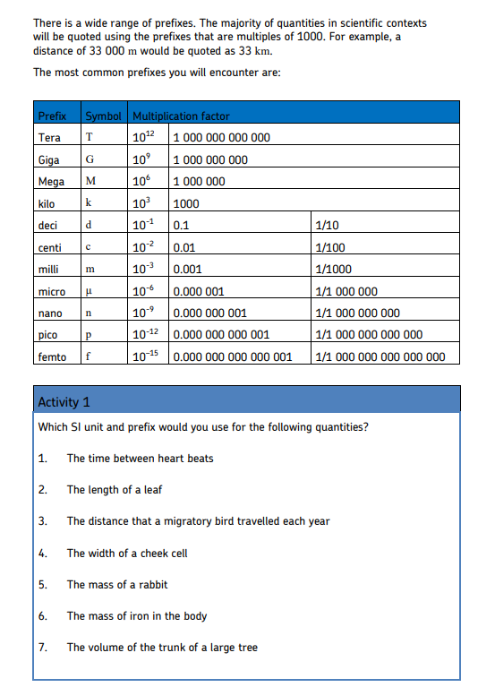
Complete the activities in the spaces provided below.
