Dear Politicos
First of all, can I welcome you to the Politics Department at Stowe school, this subject has never been more unpredictable, more alarming or more interesting. Our current 5th form have embarked upon a research project looking at 11 of the biggest most challenging questions we face in this subject. You could use the following resource to help tackle these questions, which provides articles and podcasts to help you guide your way through. The purpose of this research is not to be able to answer these questions, but rather to help elucidate these complex and difficult issues. So, even if you can’t explain the rise of Donald Trump by the end of this work – and even if you can’t solve the problem of international terrorism – you will have a clearer idea of how you might tackle these questions in your future studies.
https://www.uea.ac.uk/documents/241631/16651997/Final+Politics+Brochure+2018/bf1ad64a-1ee3-d46f-d926-b067bd6e412b
Alternatively, you might want to ensure you arrive in September with a good understanding of our contemporary political landscape by reading, watching or listening to the following;
Podcasts

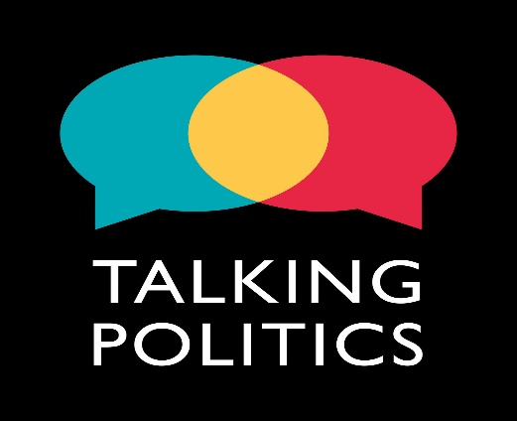https://www.talkingpoliticspodcast.com/
Talking Politics is the podcast that tries to make sense of it all. We record every week in David Runciman’s office in the Cambridge politics department with a regular panel of experts and invited guests. David and friends talk to novelists, historians, scientists, philosophers, comedians – anyone and everyone who has something interesting to say about the state we’re in. We’ll be here for the all the twists and turns of Trump’s presidency. We’ll be following the turmoil across Europe as populism confronts the establishment. We’ll be talking about Brexit as it unfolds in real time.
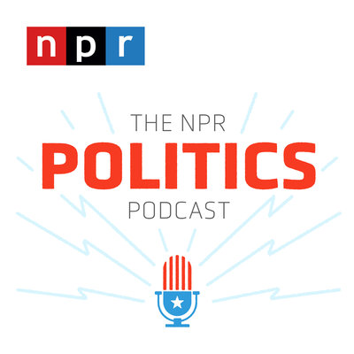https://www.npr.org/podcasts/510310/npr-politics-podcastEvery weekday, NPR's best political reporters are there to explain the big news coming out of Washington and the campaign trail. They don't just tell you what happened. They tell you why it matters. Every afternoon.
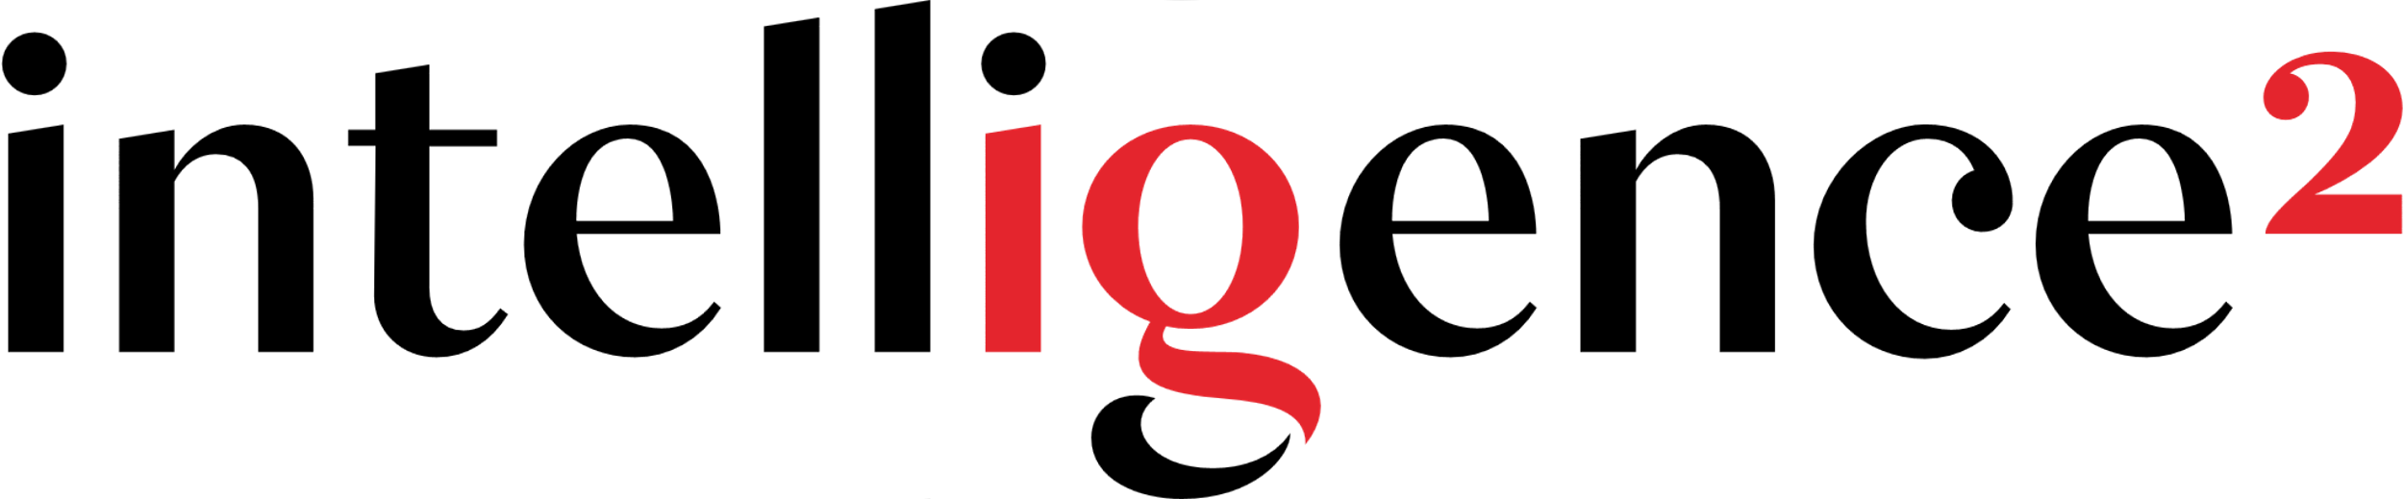
https://www.intelligencesquared.com/podcasts/
Intelligence Squared has established itself as the leading forum for live, agenda-setting debates, talks and discussions around the world.
Our aim is to promote a global conversation that enables people to make informed decisions about the issues that matter, in the company of the world's greatest minds and orators.
Free Online Politics courses
FutureLearn courses are divided into weeks. These contain various activities that you should aim to complete within the week, each one built from a sequence of straightforward steps, to help you learn. Each week is given a descriptive name, so you always know what’s expected, and you can even navigate between them, to see what’s coming up, or catch up from the beginning if you’re late starting.
https://www.futurelearn.com/subjects/politics-and-society-courses
Things to watch
Politics Live – BBC iPlayer  The Andrew Marr Show  The Politics Show | Question Time  BBC Parliament  Cabinet Confidential

Things to read
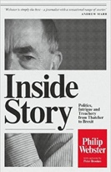
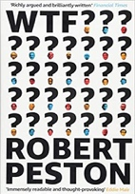
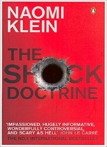
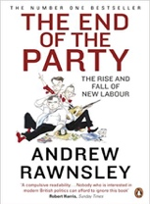
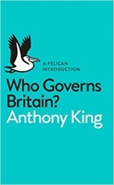
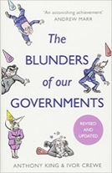
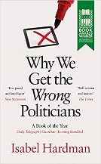

Essay competition
The John Locke Institute encourages young people to cultivate the characteristics that turn good students into great writers: independent thought, depth of knowledge, clear reasoning, critical analysis and persuasive style. Our Essay Competition invites students to explore a wide range of challenging and interesting questions beyond the confines of the school curriculum.
https://www.johnlockeinstitute.com/2020-essay-competition
Best wishes
Mr Cole
Head of Politics

