Find below a brief overview of what we are covering in the pre A Level course for Sports Science (for both A Level and BTEC pupils).

Physiology

The Cardiovascular System - focusing on Cardiac Dynamics.

Muscle Fibres - focus on muscle fibre types and their link with sporting examples

Energy System - an overview of the three different energy pathway, Aerobic, Anaerobic and ATP/PC System.

Psychology

Group Cohesion in Elite Sport - focusing on Tuckman's four stages of group formation, Carron's antecendents, Steiners Model, Social Loafing and the Ringleman effect.

Training

Principles of training applied to individual elite sports performers - using 'Don't tell me the score' podcast on Adam Gemili (athlete) and Siya Kolisi (SA Rugby player).

Socio-cultural factors

Historical development of sport from Popular Recreation to Rational Recreation - focusing on the three key sports of Football, Athletics and Tennis.

I would suggest they purchase one of the two textbooks (both available on Amazon, and other suppliers) below to help them identify the correct content:



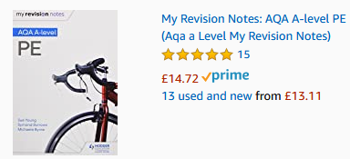

Kind regards

Andrew Jackson  
Head of Sports Science & PE