Pre-A Level subject guidance for external L6th joiners
MACROECONOMICS.
Summer Term Outline.
MACROECONOMIC FUNDAMENTALS AND THE ECONOMIC IMPACT OF COVID 19.

- Macro-Objectives.

https://www.youtube.com/watch?v=OPV1BOs1ISI
- Circular Flow.

https://www.youtube.com/watch?v=2BINy9AzHhQ

- Fiscal Policy.

https://www.youtube.com/watch?v=NEcfy0HpewQ
- Monetary Policy.

https://www.youtube.com/watch?v=uBaTPugw3M4
https://www.youtube.com/watch?v=J9wRq6C2fgo

- IMF Early View (Covid 19).

https://www.imf.org/external/mmedia/view.aspx?vid=6147509187001
https://www.imf.org/external/mmedia/view.aspx?vid=6148313391001
https://blogs.imf.org/2020/04/06/an-early-view-of-the-economic-impact-of-the-pandemic-in-5-charts/

- Blunting the impact (Covid 19).

https://blogs.imf.org/2020/03/20/blunting-the-impact-and-hard-choices-early-lessons-from-china/
https://blogs.imf.org/2020/03/05/fiscal-policies-to-protect-people-during-the-coronavirus-outbreak/
https://blogs.imf.org/2020/03/09/limiting-the-economic-fallout-of-the-coronavirus-with-large-targeted-policies/
https://www.imf.org/external/mmedia/view.aspx?vid=6149651185001

- 5 IMF Updated View.

https://www.imf.org/external/mmedia/view.aspx?vid=6149313380001
https://www.imf.org/en/Publications/WEO/Issues/2020/04/14/weo-april-2020
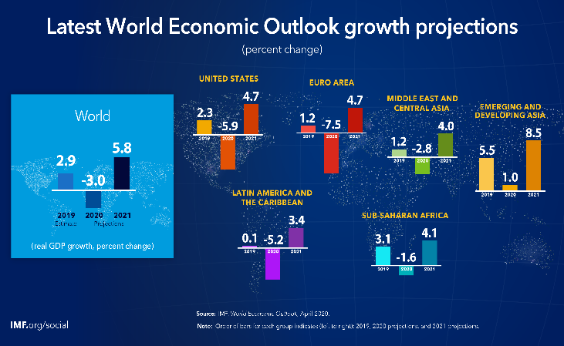
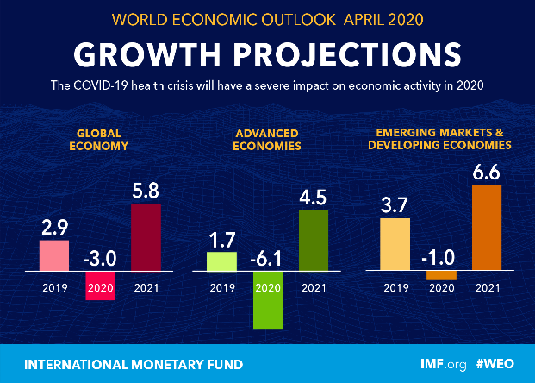

https://blogs.imf.org/2020/04/14/the-great-lockdown-worst-economic-downturn-since-the-great-depression/

- Initial Policies to support people during the Covid-19 Pandemic.

https://www.imf.org/~/media/Files/News/Podcasts/MP3/English/2020/vitor-gaspar-fm-covid-19-mix-1.ashx
https://blogs.imf.org/2020/04/15/fiscal-policies-to-contain-the-damage-from-covid-19/
https://www.imf.org/en/Publications/FM/Issues/2020/04/06/fiscal-monitor-april-2020
https://www.imf.org/en/Publications/FM/Issues/2020/04/06/fiscal-monitor-april-2020

- OBR UK Forecast on the Economic Impact of Covid-19.

https://cdn.obr.uk/The_OBRs_coronavirus_analysis.pdf

- A Regional Analysis on the Economic Impact of Covid 19

https://www.imf.org/en/Publications/REO/SSA
https://www.imf.org/en/Publications/REO/APAC

