Committed to delivering a safe environment

www.safegolf.org
for golf

Is something worrying you?
Do you need someone to talk to?

Speak to your club welfare officer
joesullivan1967@googlemail.com
07778 958111
Joe Sullivan

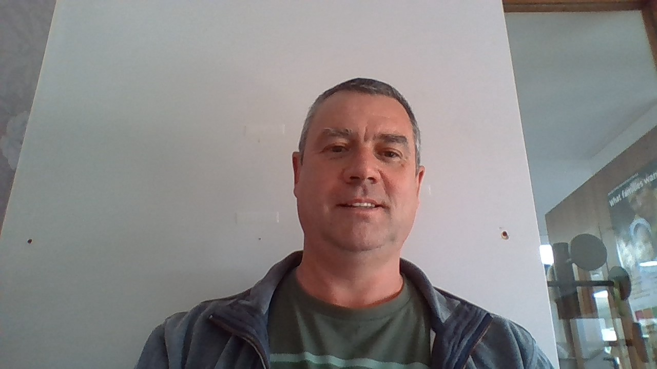

ADD PHOTO
HERE
Alternatively, you can speak to someone at
ChildLine 0800 1111
ABOUT ME

I am an avid golfer and have been for some years. I am employed by Oxfordshire County Council in the capacity of Senior Family Support Worker where i work with the most vulnerable and disadvantaged children. I am a qualified Designated Safeguarding Lead within Children's Services. Please contact me if you have any issues or concerns.
NSPCC 0808 800 5000
England Golf 01526 351851

Club
WELFARE

officer

